Mistakes I’ve Made: NQT to Assistant Head
researchED Northampton
5th October
Douglas Wise
@DoWise

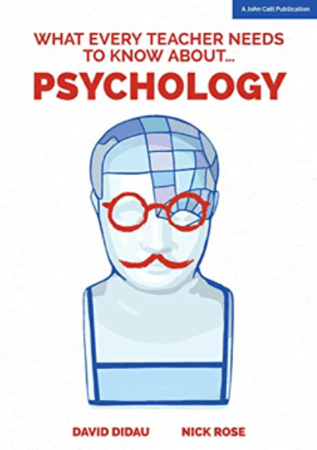 | 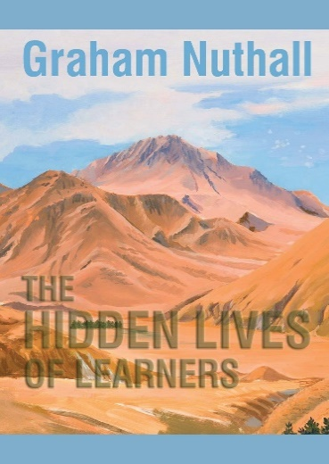
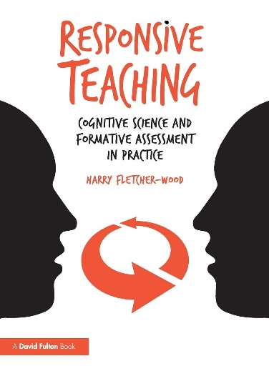 | 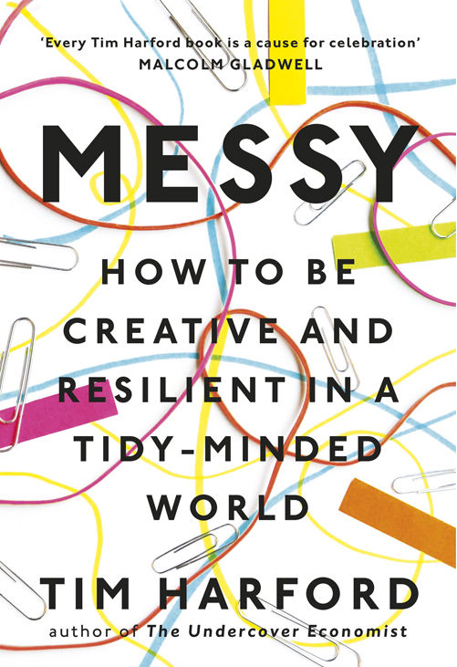
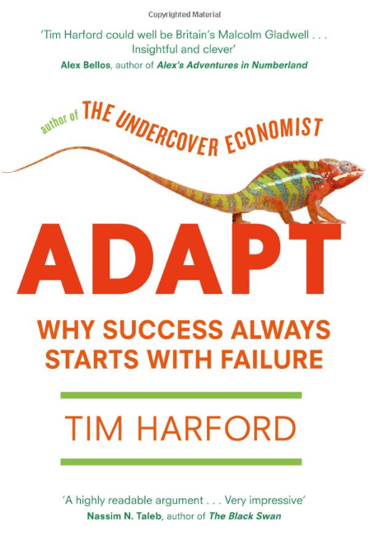 | 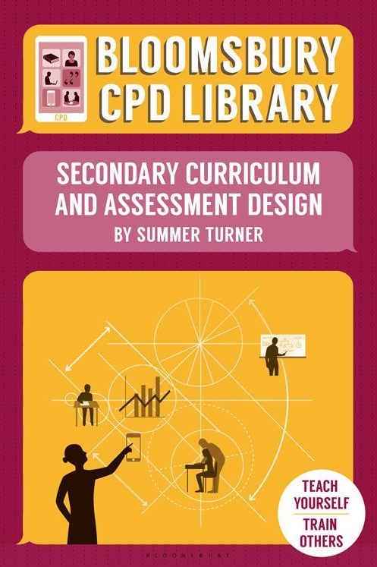



The biggest mistake I made was to believe that learning could be reliably and neatly split into single lesson units
Blog: https://www.douglaswise.co.uk/mistakes-ive-made-nqt-year/

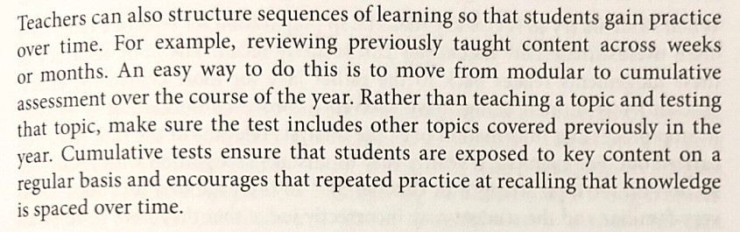
Source: What Every Teacher Needs to Know About Psychology, by David Didau and Nick Rose (p.115)

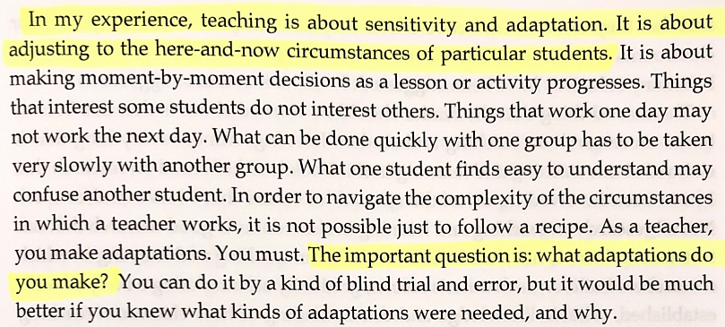
Source: The Hidden Lives of Learners, by Graham Nuttall (p.15)

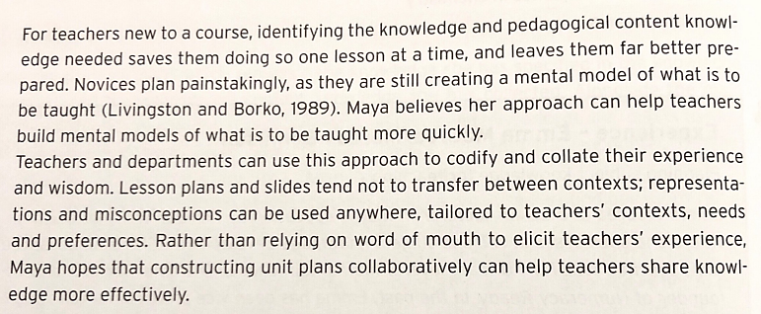
Source: Responsive Teaching, by Harry Fletcher-Wood (p.30)
I failed to meaningfully celebrate the many and varied successes of the majority of my students
Blog: https://www.douglaswise.co.uk/head-of-year-mistakes/

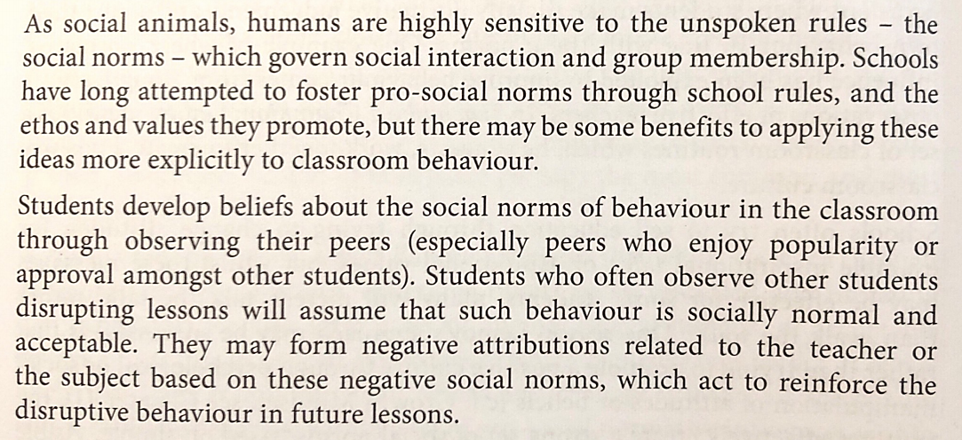
Source: What Every Teacher Needs to Know About Psychology, by David Didau and Nick Rose (p.196)

I thought that questions about the decisions I made or the views I held were criticisms of my ability to do the job
Blog: https://www.douglaswise.co.uk/some-advice-for-newish-or-aspiring-heads-of-department/

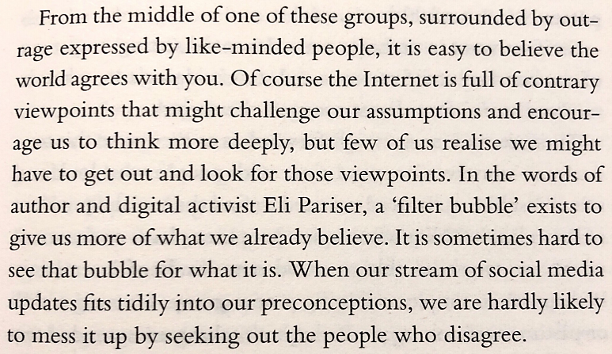
Source: Messy, by Tim Harford (p.61)

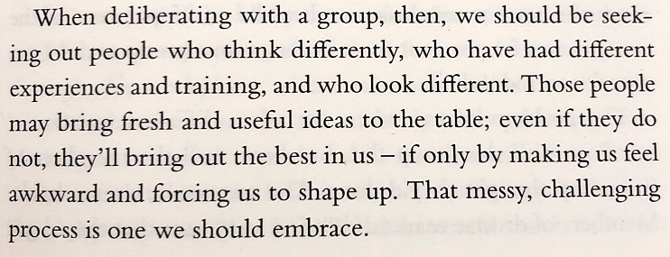
Source: Messy, by Tim Harford (p.35)

I failed to pause long enough to consider the impact of my decisions on those around me and the opportunity costs
Blog: https://www.douglaswise.co.uk/assistant-headteacher-mistakes/

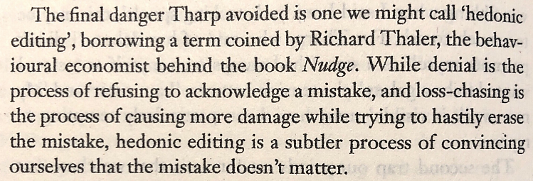
Source: Adapt: Why Success Always Starts with Failure, by Tim Harford (p.254)

Teaching requires such a high level of sensitivity to factors that are largely beyond our control
Blog: https://www.douglaswise.co.uk/teaching-experience-matters/

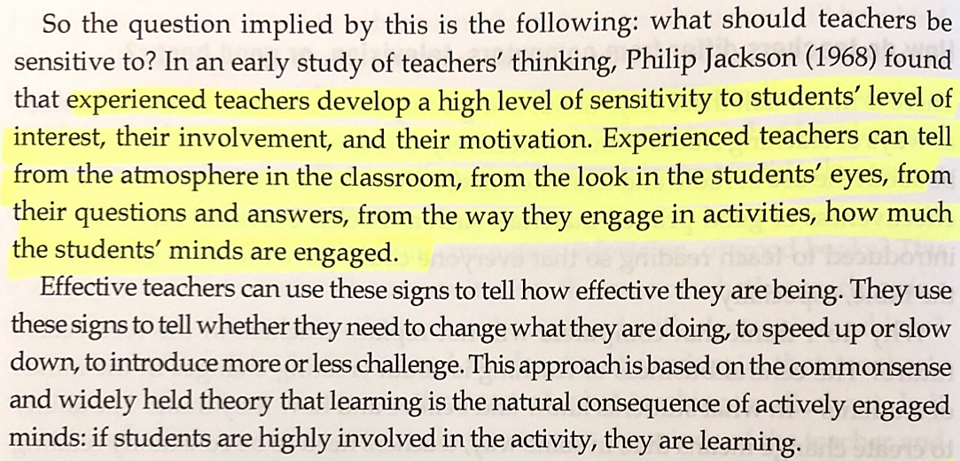
Source: The Hidden Lives of Learners, by Graham Nuttall (p.24)

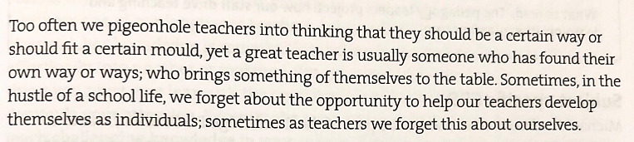
Source: Secondary Curriculum and Assessment Design, by Summer Turner (p.205)

